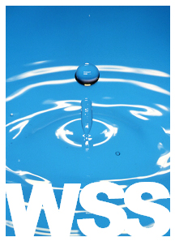 | Your one stop source for all your water needs | ORDER FORM

Water Systems & Supplies  12802 Knott Street, Garden Grove, CA 92841  Telephone: 714.893.4886 Fax: 714.903.2715  sales@wssusa.com |  | Date: July 30, 2026
TO |  | ship  to

qty | item # | description | unit price | discount | line total
Please fax or email to us. A sales order will be sent to your shortly.
Thank you for your business!

